**REPORT ON LAB 1 - NT219.O11.ANTN**

**Student: Bùi Vương Tâm Anh**

**Student Numbe: 22520039**

# Table of Contents

1. Hardware Specs
2. Comparison between Windows and Linux
3. Review

# Hardware Specs

1. Windows:

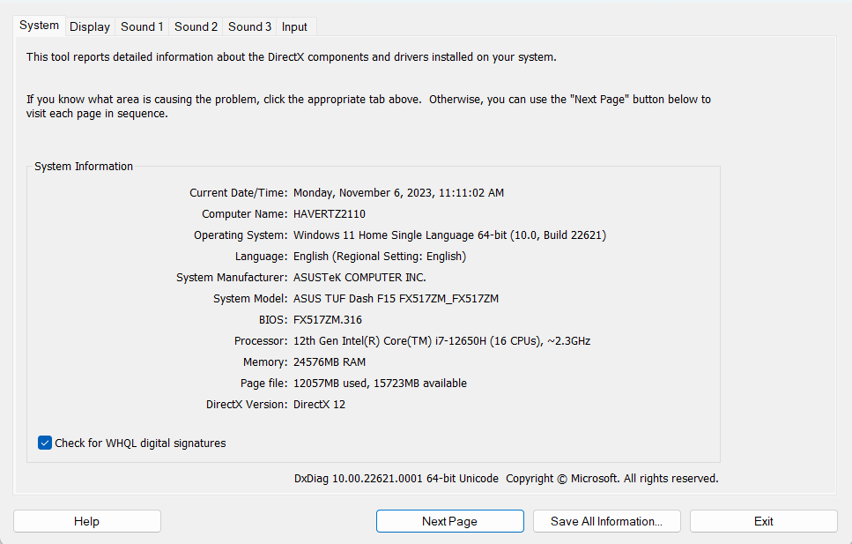

b. Ubuntu

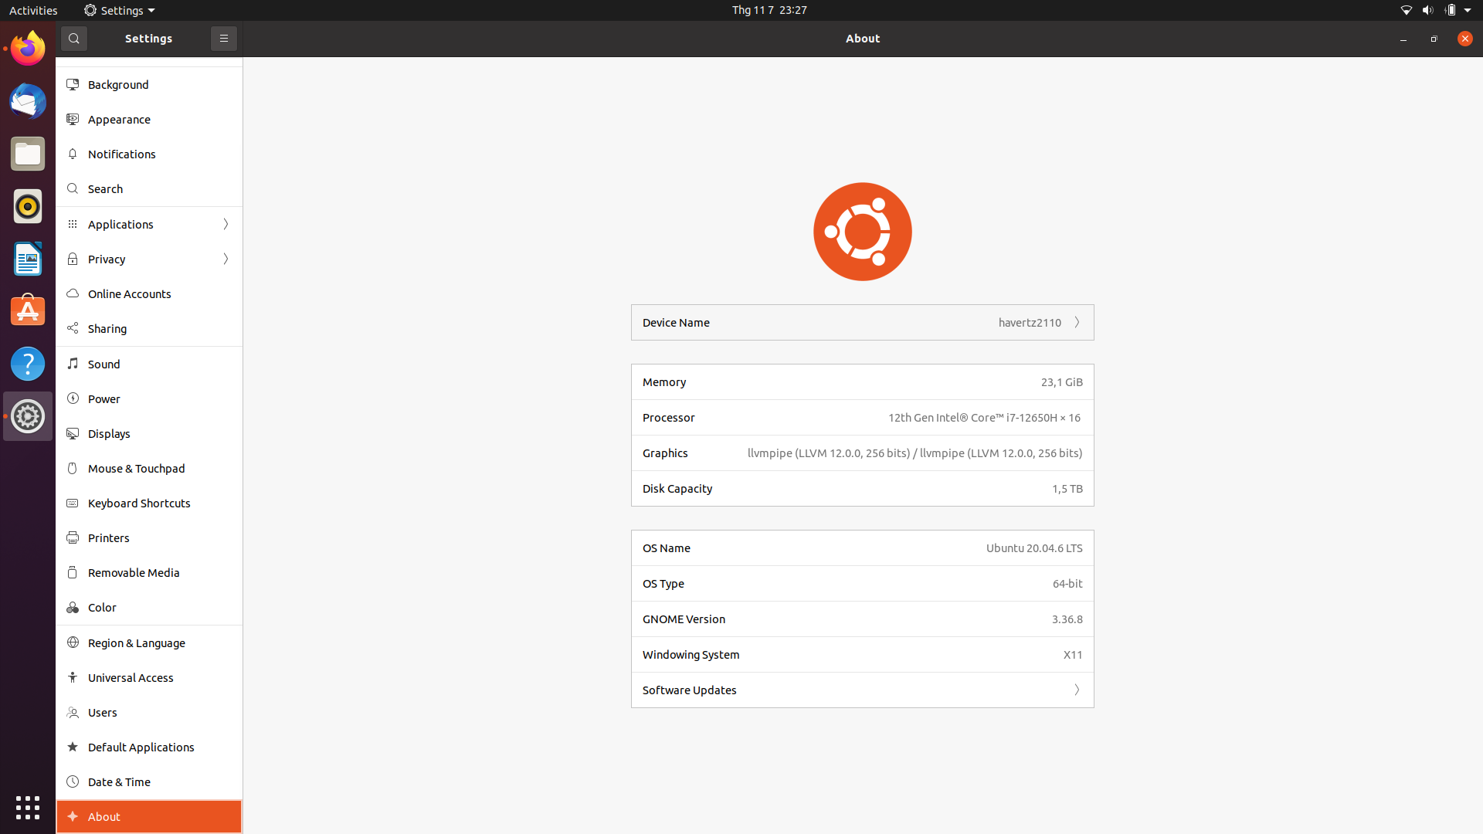

# Comparison Table

* 1. ECB

|  |  |  |  |  |  |
| --- | --- | --- | --- | --- | --- |
|  |  | Windows | | Ubuntu | |
|  | Size | Encrypt | Decrypt | Encrypt | Decrypt |
| Test 1 | 5 KB | 0.0034 | 0.0662 | 0.0047 | 0.1242 |
| Test 2 | 50 KB | 0.0217 | 0.6304 | 0.0361 | 0.7804 |
| Test 3 | 100 KB | 0.042 | 1.1789 | 0.0711 | 1.5432 |
| Test 4 | 500 KB | 0.2711 | 6.7578 | 0.4505 | 7.902 |
| Test 5 | 1 MB | 0.5565 | 22.2769 | 0.9102 | 24.5752 |
| Test 6 | 2 MB | 5.2404 | 35.5764 | 4.9102 | 40.1242 |

* 1. CBC

|  |  |  |  |  |  |
| --- | --- | --- | --- | --- | --- |
|  |  | Windows | | Ubuntu | |
|  | Size | Encrypt | Decrypt | Encrypt | Decrypt |
| Test 1 | 5 KB | 0.0058 | 0.0642 | 0.0084 | 0.2105 |
| Test 2 | 50 KB | 0.0445 | 0.6372 | 0.0658 | 1.2432 |
| Test 3 | 100 KB | 0.0876 | 1.2249 | 0.1294 | 1.6792 |
| Test 4 | 500 KB | 0.4906 | 7.1912 | 0.7381 | 10.2012 |
| Test 5 | 1 MB | 1.0376 | 12.5742 | 1.4953 | 14.2451 |
| Test 6 | 2 MB | 6.1995 | 32.5067 | 5.21 | 37.2421 |

* 1. OFB

|  |  |  |  |  |  |
| --- | --- | --- | --- | --- | --- |
|  |  | Windows | | Ubuntu | |
|  | Size | Encrypt | Decrypt | Encrypt | Decrypt |
| Test 1 | 5 KB | 0.0059 | 0.0652 | 0.0078 | 0.0981 |
| Test 2 | 50 KB | 0.0445 | 0.6464 | 0.0654 | 0.9682 |
| Test 3 | 100 KB | 0.0898 | 1.4334 | 0.1295 | 1.9212 |
| Test 4 | 500 KB | 0.4987 | 7.3022 | 0.7273 | 7.992 |
| Test 5 | 1 MB | 1.0371 | 13.2782 | 1.4779 | 16.2145 |
| Test 6 | 2 MB | 5.5409 | 29.3124 | 4.7821 | 31.2425 |

* 1. CFB

|  |  |  |  |  |  |
| --- | --- | --- | --- | --- | --- |
|  |  | Windows | | Ubuntu | |
|  | Size | Encryp | Decrypt | Encrypt | Decrypt |
| Test 1 | 5 KB | 0.0057 | 0.0618 | 0.0083 | 0.0925 |
| Test 2 | 50 KB | 0.0456 | 0.6083 | 0.0664 | 0.9224 |
| Test 3 | 100 KB | 0.0897 | 1.277 | 0.1334 | 1.6921 |
| Test 4 | 500 KB | 0.5146 | 9.0375 | 0.7556 | 10.9201 |
| Test 5 | 1 MB | 1.09 | 14.2124 | 1.5229 | 16.7452 |
| Test 6 | 2 MB | 5.2975 | 28.6542 | 4..42 | 29.918 |

* 1. CTR

|  |  |  |  |  |  |
| --- | --- | --- | --- | --- | --- |
|  |  | Windows | | Ubuntu | |
|  | Size | Encrypt | Decrypt | Encrypt | Decrypt |
| Test 1 | 5 KB | 0.0036 | 0.0612 | 0.0053 | 0.0921 |
| Test 2 | 50 KB | 0.0219 | 0.6821 | 0.0382 | 0.8978 |
| Test 3 | 100 KB | 0.0427 | 1.2446 | 0.0749 | 1.8241 |
| Test 4 | 500 KB | 0.2978 | 9.0012 | 0.4685 | 9.9998 |
| Test 5 | 1 MB | 0.639 | 13.1729 | 0.9275 | 16.2145 |
| Test 6 | 2 MB | 5.1297 | 26.1224 | 4.1298 | 29.1022 |

* 1. XTS

|  |  |  |  |  |  |
| --- | --- | --- | --- | --- | --- |
|  |  | Windows | | Ubuntu | |
|  | Size | Encrypt | Decrypt | Encryp | Decryp |
| Test 1 | 5 KB | 0.0055 | 0.0762 | 0.0071 | 2.43 |
| Test 2 | 50 KB | 0.0396 | 0.7592 | 0.0582 | 4.2347 |
| Test 3 | 100 KB | 0.0825 | 1.4224 | 0.1207 | 8.7422 |
| Test 4 | 500 KB | 0.5012 | 9.1232 | 0.7311 | 11.2819 |
| Test 5 | 1 MB | 1.2094 | 13.1209 | 1.4765 | 20.4242 |
| Test 6 | 2 MB | 6.2484 | 29.8312 | 5.2531 | 31.198 |

* 1. CCM

|  |  |  |  |  |  |
| --- | --- | --- | --- | --- | --- |
|  |  | Windows | | Ubuntu | |
|  | Size | Encrypt | Decrypt | Encrypt | Decrypt |
| Test 1 | 5 KB | 0.0064 | 0.7824 | 0.0086 | 1.98 |
| Test 2 | 50 KB | 0.0493 | 2.623 | 0.0811 | 4.521 |
| Test 3 | 100 KB | // | // | // | // |
| Test 4 | 500 KB | // | // | // | // |
| Test 5 | 1 MB | // | // | // | // |
| Test 6 | 2 MB | // | // | // | // |

* 1. GCM

|  |  |  |  |  |  |
| --- | --- | --- | --- | --- | --- |
|  |  | Windows | | Ubuntu | |
|  | Size | Encrypt | Decrypt | Encrypt | Decrypt |
| Test 1 | 5 KB | 0.0045 | 0.1382 | 0.0058 | 0.1783 |
| Test 2 | 50 KB | 0.0277 | 0.2242 | 0.0427 | 0.9012 |
| Test 3 | 100 KB | 0.0547 | 1.4284 | 0.0836 | 1.6546 |
| Test 4 | 500 KB | 0.3341 | 8.2124 | 0.5083 | 9.887 |
| Test 5 | 1 MB | 0.6538 | 20.2418 | 1.0356 | 18.9828 |
| Test 6 | 2 MB | 6.5887 | 28.1324 | 5.2312 | 29.102 |

# Review

Thời gian chạy trong Windows và Linux gần bằng nhau, nhưng trong vài trường hợp thì Linux chạy nhanh hơn rất nhiều và cũng trong vài trường hợp thì Windows chạy nhanh hơn.

Tuy nhiên ở các trường hợp Linux của em chạy chậm hơn, em nghĩ rằng do cấu hình Dual Boot của em không thực sự mạnh mẽ bởi khi tham khảo từ trên mạng, ChatGPT và các bạn cùng lớp, em thấy rằng hầu hết họ đều chạy bên Linux nhanh hơn.